D597 Task 2
Part 1: Design Document
- Scenario 2
- Business problems that require a database solution:
- Data is constantly evolving, with products being added, updated, and changed regularly.
- Large amounts of data require horizontal scaling to support growth volume and ensure optimal performance.
- Unstructured data will require a flexible database to manage data efficiently.
- NoSQL databases are designed to work with flexible data models and unstructured data and are compatible with nested documents and JSON files. NoSQL databases prioritize horizontal scalability and can implement robust security measures.
- The scenario recommends a document-oriented database because it is compatible with EcoMart’s data, stores it in JSON files, and is a flexible database solution that meets their business needs. Schaefer (n.d.) further mentions another important design driver is the types of data access that need to be supported, as some use cases will require access via a query language, and others will require access by one or more applications. EcoMart’s database can provide these options as well.
- The database will use documents with embedded subdocuments and arrays, which will require no schema update as data changes. EcoMart can query the database by Label, Brand, Name, Price, Rank, Ingredients, Item Description, and Item Purchase Date. Together, EcoMart can compare inventory, customer ratings, and prices over time.

- Our NoSQL database will address scalability concerns through horizontal scaling and sharding, so records are distributed across servers, and indexing is performed on the most searched fields, including indexes on Price, Rank and Label, based on query patterns and business workflows. As the database grows, Schaefer (n.d.) emphasizes, “the predicted size of the index also has a bearing on how data is stored.” This means that the document size will impact the index storage size, so considering data-efficient storage solutions early can manage the volume of data and the speed of the database.

- Robust security measures can include encryption, access controls, and audit logging. Authentication to authorize connections between users and applications, role-based access controls to grant specific staff members database permissions as needed, and encryption tools would protect data that is stored.

Part 2: Implementation

D. Implement Proposed Database
1. Database D597 Task 2 Created
2. Cosmetics and Groceries tables inserted and mapped in the database
3. Three queries to retrieve specific information from the database:
- What products have a 4-star rating or higher?

db.Cosmetics.find({Rank: {$gte: 4} }, {Label: true})

- How many products are over $200?

db.Cosmetics.find( {Price: {$gt:200} }, { Label:true})

- How much tropical fruit is in the Grocery Collection?
db.Groceries.countDocuments ({itemDescription: "tropical fruit"})

4. Indexes created on Price, Rank, and Label
Question 1: Before Index
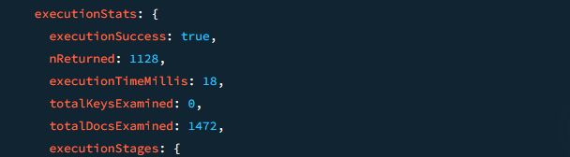
This question is reviews ratings to gather insights into customer reviews. Our first execution examined 1472 total documents in 18 seconds. After adding our indexes to Price, Rank, and Label, our second execution examined 1128 total documents in 3 seconds. Our indexes improved the performance of our database by enabling quicker query that review fewer documents. With indexes consuming storage and adding overhead to inserts and updates, I’d recommend that our database administrator keep these indexes unless another is more useful.
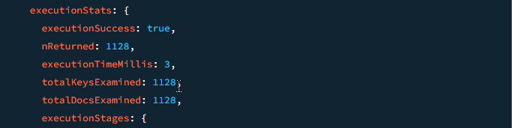

Question 2: Before Index
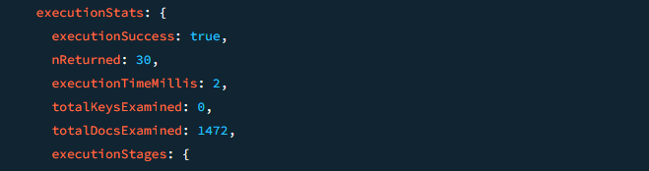
This question is asking how many products are over $200 to gather insights into product pricing. Our first execution examined 1472 documents in 2 seconds. After applying the indexes Price, Rank, and Label, our second execution examined 30 documents in 0 seconds. This index is improving our database query speed and reducing the number of documents examined.

Question 3: Before Index

This question reviews how any tropical fruits are in the Grocery inventory. To use the execution stats with count documents, we aggregated our query. Before the index, the first execution examined 38,765 documents in 27 seconds. After adding the index, the second execution examined 38.765 documents in 26 seconds. In this case, we can see our indexes didn’t really affect these queries because we don’t use them here. This would be a reason to delete them if other values are searched for more often.


References
Schaefer, L. (n.d.). NoSQL database design & data modeling. MongoDB. https://www.mongodb.com/resources/basics/databases/nosql-explained/data-modeling

